Survey Analysis

Non Destructive Testing

Table of Contents

###### Report Information

|  |  |
| --- | --- |
| Prepared for | International Atomic Energy Agency |
| Prepared by | Julian King, Kate McKegg, Andres Arau, Aaron Schiff, Martina Garcia Aisa |
| Cover image |  |
| Citation | King,J., McKegg, K., Arau, A., Schiff, A., Garcia Aisa, M. (2021). *Social and Economic Impact Assessment of the RCA Programme: Non Destructive Testing Case Study.* Vienna, Austria: International Atomic Energy Agency. |

## Disclaimer

The information in this document is presented in good faith using the information available to us at the time of preparation. It is provided on the basis that the authors of the document are not liable to any person or organisation for any damage or loss which may occur in relation to taking or not taking action in respect of any information or advice within this document

## Acknowledgements

The authors are grateful for the close and effective assistance of the Technical Cooperation division for Asia-Pacific (TCAP) and Technical Cooperation Division of Programme Support and Coordination (TCPC) of the International Atomic Energy Agency (IAEA), and the experts from the 22 participating countries in the the Non-Destructive Testing Regional Cooperative Agreement (RCA): Australia, Bangladesh, Cambodia, China, Fiji, India, Indonesia, Japan, Laos, Malaysia, Mongolia, Myanmar, Nepal, New Zealand, Pakistan, Palau, Philippines, Singapore, South Korea, Sri Lanka, Thailand, and Viet Nam

# Acronyms

|  |  |
| --- | --- |
| Name | Acronym |
| Asia Pacific Federation of NDT | APFNDT |
| Eddy Current System | ET |
| Government Party | GP |
| International Atomic Energy Agency | IAEA |
| International Commitee on Non-destructive Testing | ICNDT |
| Multilateral Recognition Agreement | MRA |
| Magnetic Particle Testing | MT |
| National Certification Body | NCB |
| Non Destructuve Testing | NDT |
| Liquid Penetrant Testing | PT |
| Quality Assurance | QA |
| Quality Control | QC |
|  | RCVA |
| Radiographic Testing Method | RT |
| Time of Fligth Diffraction | TOFD |
| Ultrasonic Testing | UT |

# Main findings

* Out of the 22 countries that are part of the Regional Cooperative Agreement (RCA) for Research (Development and Training in Non-Destructive Testing (NDT) in Asia and the Pacific), 20 participated in the online survey: Australia, Bangladesh, Cambodia, China, India, Indonesia, Japan, Laos, Malaysia, Mongolia, Myanmar, Nepal, New Zealand, Pakistan, Philippines, Singapore, South Korea, Sri Lanka, Thailand, and Vietnam. **The support and cooperation of country representatives and IAEA staff during these unusual circumstances is gratefully acknowledged**.
* Out the 22 countries that are part of RCA, 18 currently act as recipients of the IAEA Technical Co-operation Programme (TCP). The other four (Australia, Japan, New Zealand, and very recently Korea) have voluntarily decided not to receive the IAEA TCP, but they work as resource countries to provide support for the IAEA TCP. **Based on this definition, the three countries that have historically acted as non-recipients (Australia, Japan and New Zealand) are excluded from the assessment of the criteria and level of performance conducted in this analysis. Given their historically non-recipient character, any assessment of the performance of RCA to accelerate and enlarge the application of NDT technologies in those countries would result in a misinterpretation of the results.**
* Eleven out of the eighteen recipient Government Parties (GPs) have established a National Certification Body (NCB), and 60% of them perceived that the RCA programme has contributed to a great extent in the establishment of their body.
* From 2000 to 2020, the NDT RCA programme has contributed, yearly, to the certification of roughly 12,657 personnel by local NDT Accredited Training Centres in 15 countries. From the total certified personnel, 6.2% are female.
* The method for which RCA has contributed the most to the certification of personnel is Radiographic Testing (10,609 personnel certified per year), followed by Magnetic Testing and Penetrant Testing.
* There are over 3,607 inspection centres owned by local firms across all the GPs that participate in the NDT RCA programme. According to respondents from the GPs, the RCA NDT programme has contributed to a great extent in the establishment of inspection centres in nine of the eighteen countries that are recipients of the programme.
* 75% of GPs that have established any R&D activities related to NDT and 1,620 publications related to NDT that have been published since 2000 are result of being part of the RCA NDT programme.
* 85% of GPs reported that the RCA NDT programme contributed to NDT technologies being applied for safer operations of nuclear and other industrial installations.
* For 83% of the recipient GPs, RCA NDT has helped to speed up the adoption of NDT technologies in their country.
* 78% of the recipient GPs reported that NDT RCA has contributed to the adoption of NDT technologies by private business in their countries since 2000. Half of these countries estimated that 25% or more of the total activity in their NDT sector can be attributed to being involved in the NDT RCA programme.
* 82% of the receipient GPs consider that the role of IAEA/RCA activities in achieving the general objectives and benefits of NDT on socio-economic impact through industrial growth in their countries is excellent or good.

# Introduction

This report presents the findings of the Social and Economic Impact Assessment of Non Destructive Testing (NDT) of the RCA in Asia and the Pacific. The data that informs the analysis was collected through an online survey that was designed and piloted in May 2021 and deployed between June and August 2021. The respondents to the survey were national experts on the field of NDT. They provided relevant information about the equipment, training centres, certified personnel, and the health and safety impacts of the RCA programme in their country.

From the 22 countries that are part of the Cooperative Agreement for Research (RCA), 20 participated in the survey: Australia, Bangladesh, Cambodia, China, India, Indonesia, Japan, Laos, Malaysia, Mongolia, Myanmar, Nepal, New Zealand, Pakistan, Philippines, Singapore, South Korea, Sri Lanka, Thailand, and Vietnam.

Figure: 1 below shows the countries that participated in this study

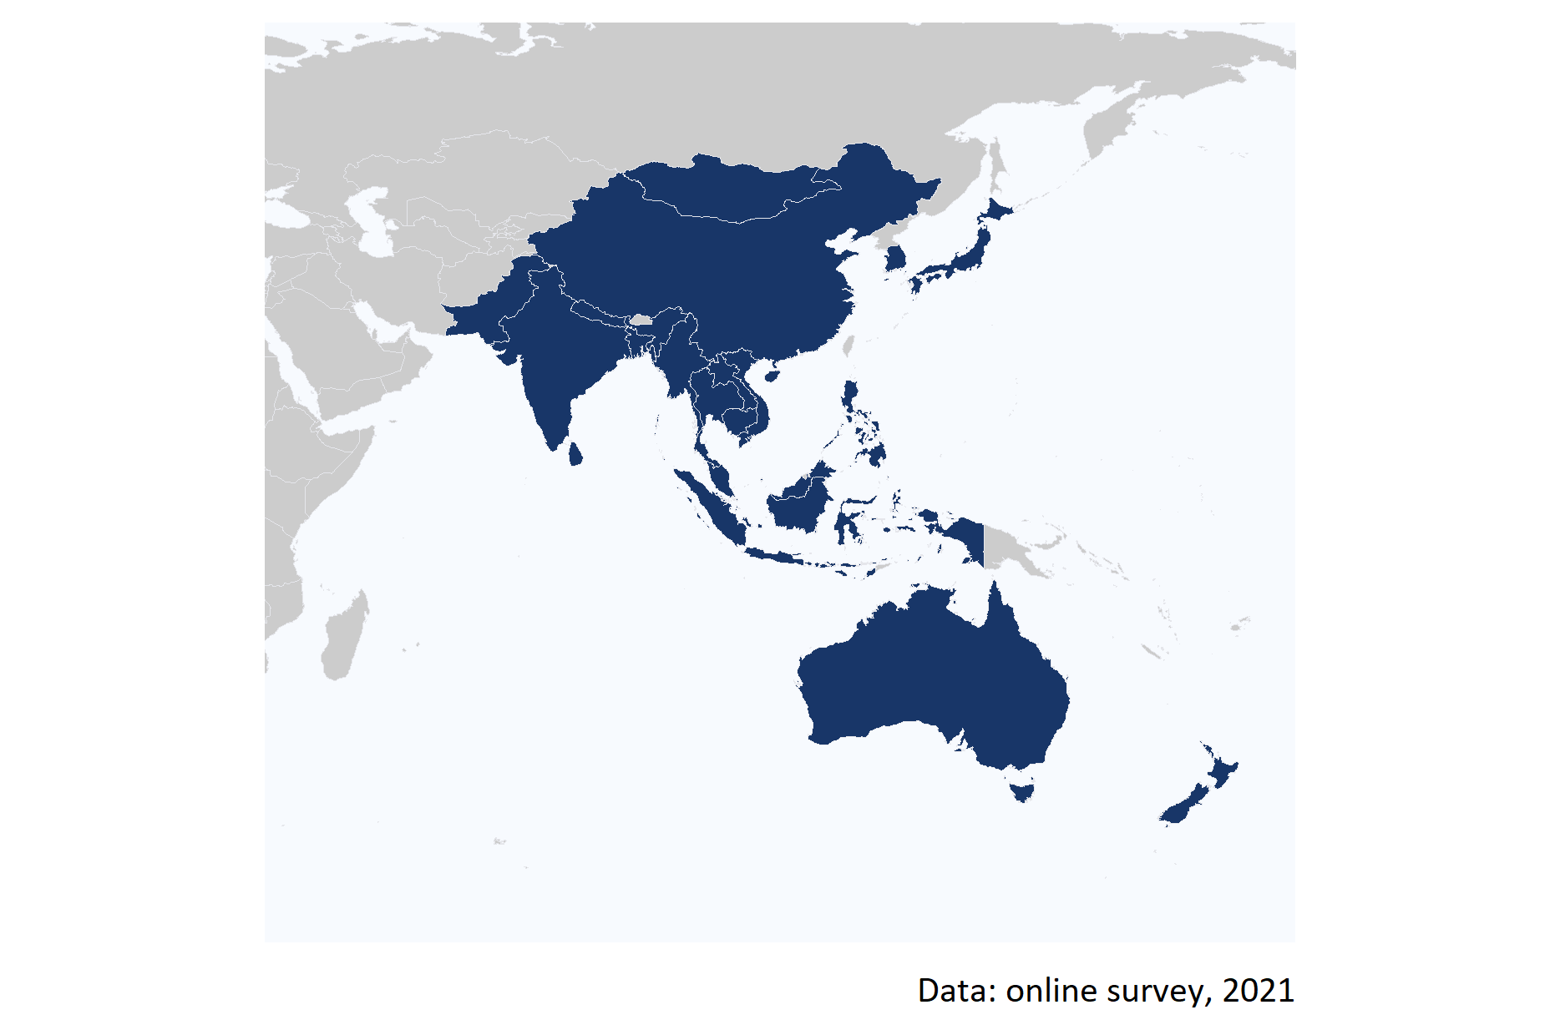

Figure 1: Map of the 20 countries that participated in the online survey.

The assessment of the social and economic impacts of the NDT RCA programme involved pre-defining agreed performance criteria (aspects of social and economic impacts that were the focus of the evaluation) and standards (narratives describing four levels of performance – excellent, good, adequate, and inadequate). These criteria and standards (detailed in Annex G) provided a transparent and robust framework for rating the impact of the NDT RCA.

To understand the contribution of the NDT RCA programme on social and economic indicators, the study analyses the extent to which being part of the programme has enabled the GPs to:

**Improve NDT capacity and capability**

1. Fulfill the Multilateral Recognition Agreement (MRA) requirements of the International Committee on Non-destructive Testing (ICNDT) as a result of the support under the NDT RCA programme;
2. Establish GPs’ NDT infrastructure to produce certified personnel in advanced techniques (Radiographic Testing - Digital , Phased Array Ultrasonic Testing, Time of Flight Diffraction , and Pulsed Eddy Current), in addition to the conventional methods (Radiographic Testing, Ultrasonic Testing, Magnetic Testing, Penetrant Testing , and Eddy Current Testing);
3. Achieve self-reliance in NDT, including offering training and inspection activities to local industries as well as abroad;

**Increase scope and scale of NDT demand and use**

1. Enhance awareness, interest, and application of NDT technology in the industrial sectors for the quality assurance (QA) and quality control (QC) of industrial components;
2. Develop knowledge developed through R&D by publishing research articles, organising international and national seminars and conferences; and

**Improved health and safety**

1. Improve health and safety by applying NDT technology in the industrial sectors.

It is worth mentioning that the IAEA Technical Co-operation Programme (TCP) has been established by the IAEA to support IAEA Member States (MSs) (especially developing countries) to accelerate and enlarge the application of nuclear technologies in a safe, secure, effective, and efficient manner. In principle, every IAEA MS can receive and enjoy the benefit of the IAEA TCP. However, some MSs (especially developed/advanced MSs) volunteer not to receive the IAEA TCP, but they work as resource countries to provide support for the IAEA TCP. Under the RCA, there are 22 countries, of which 18 countries are TC recipients and 4 are TC non-recipients (Australia, Japan, New Zealand, and very recently Korea). **Based on this definition, the three countries that have historically acted as non-recipients (Australia, Japan and New Zealand) are excluded from the assessment of the criteria and level of performance conducted in this analysis. Given their historically non-recipient character, any assessment of the performance of RCA to accelerate and enlarge the application of NDT technologies in those countries would result in a misinterpretation of the results.**

Figure 2 summarises the performance of each GP against the defined criteria (aspects of performance) and standards (levels of performance).

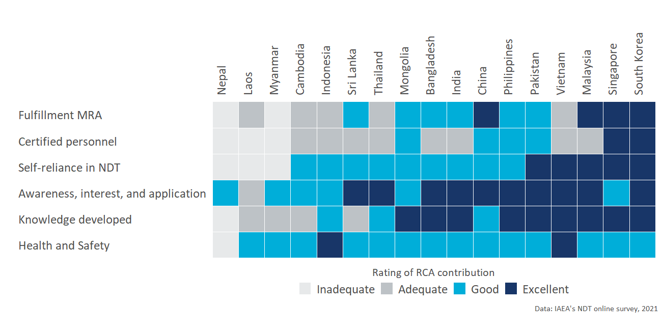

Figure 2: Performance standard by criterion and country

The complete analysis for all the aspects of performance is presented in the next sections.

# Criterion 1: Improved NDT capacity and capability

To understand the contribution of the NDT RCA programme to developing the capacity and capability of the Government Parties (GPs), this section presents the results of the assessment of the extent to which the support of the NDT RCA programme has enabled GPs to:

1. Fulfill the Multilateral Recognition Agreement (MRA) requirements of the International Committee on Non-destructive Testing (ICNDT) as a result of the support under the NDT RCA programme;
2. Establish GPs’ NDT infrastructure to produce certified personnel in advanced techniques (RT-D, PAUT, TOFD, PEC, etc), in addition to the conventional methods (RT, UT, MT, PT, ET); and
3. Achieve self-reliance in NDT, including offering training and inspection activities to local industries as well as abroad.

Key results of this assessment are summarized in the below table.

Key evidence for criterion 1: Improved NDT capacity and capability

|  |  |  |
| --- | --- | --- |
| Sub-criterion | Evidence | Finding |
| Fulfillment of MRA | % Of recipient GPs that have established a National Certification Body | 61% |
| Fulfillment of MRA | % Of recipient GPs that have established a National Certification Scheme | 82.3529411764706% |
| NDT infrastructure to produce certified personnel | Average personnel certified in conventional and advanced techniques under NDT RCA per year for the period 2000 to 2020 | 12,657 |
| Self-reliance in NDT | Inspection centres owned by local firms | 3,607 |
| Self-reliance in NDT | Training centres owned by local firms | 191 |

Moreover, Figure 3 below shows each GP’s levels of performance in developing their capacity and capability for each NDT dimension.

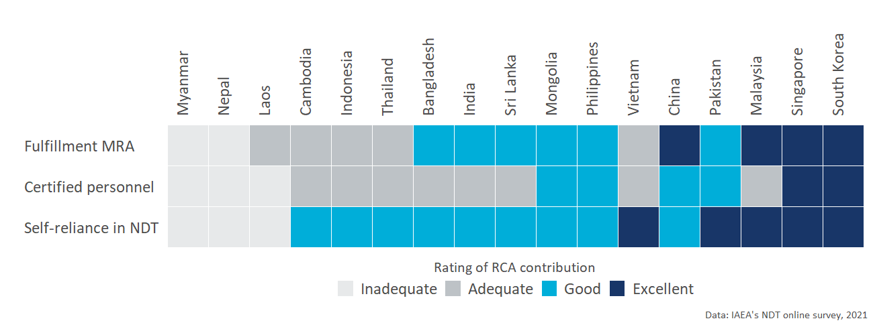

Figure 3: Capacity and capability of the Government Parties (GPs): Performance standard by criterion and country

The detailed analysis of each sub-criterion under improved NDT capacity and capability is presented in the sections below.

## Sub-criterion 1.1: Fulfillment of the Multilateral Recognition Agreement

This criterion aims to understand the the extent to which a GP has fulfilled the MRA requirements of ICNDT and the status of the NDT infrastructure at the national level. The standards (levels of performance) for the Fulfillment of the Multilateral Recognition Agreement are the following:

* **Adequate:** GPs have established a National Certification Scheme (NCS).
* **Good:** GPs have established a NCS and a National Certification Body (NCB) on NDT.
* **Excellent:** GPs’ NDT Society is registered with APFNDT and ICNDT, the society is a signatory to ICNDT MRA, NCB for NDT has been accredited to ISO 17024, and NCB has accepted for registration under the ICNDT MRA.

### Performance standards of “Fulfillment of the Multilateral Recognition Agreement”

From the 18 countries that act as recipients of RCA, only Nepal and Myanmar have not established a National Certification Scheme yet; Almost all countries but Laos, Cambodia, Nepal, and Myanmar have registered their NDT society in the Asia Pacific Federation of NDT (APFNDT); and for 8 out of the 18 recipient GPs, their NCB for NDT has been accredited to ISO 17024.

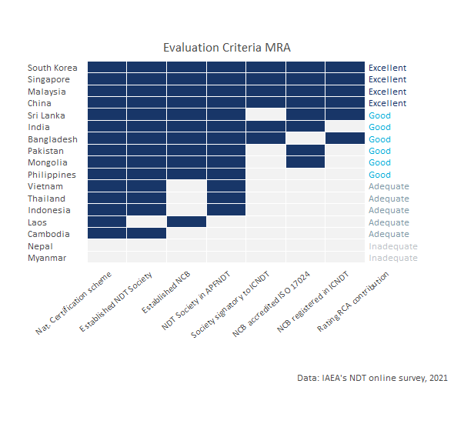

Figure 4: NDT infrastructure at the national level and assessment standards.

Based on the criterion developed with IAEA to assess the performance of GPs in terms of Fulfillment of the Multilateral Recognition Agreement, China, Malaysia, Singapore, and South Korea met excellent performance standards on this criterion (See criterion and standards in Annex A)

Figure 4 above shows the level of NDT infrastructure that each recipient GP has established and the performance for this criterion.

### Contribution of the NDT RCA in GP’s establishing a NCB and NCS

To assess the contribution of RCA in the establishment of a National Certification Body (NCB) and National Certification Schemes (NCS), the participants of the online survey were asked the extent to which they perceive that the RCA NDT programme has contributed to the establishment of this infrastructure in their countries.

As it can be seen in the Figure 5 below, from the eleven GPs that have established a NCB under RCA, ten **(Bangladesh, China, Laos, Malaysia, Mongolia, Pakistan, Philippines, Singapore, South Korea, and Sri Lanka) perceived that the RCA programme has contributed to a great extent in the establishment of their body**. As it was expected (because of their historical role as non-recipient countries), only Australia, Japan, and New Zealand perceive that the establishment of their NCB could have been achieved without the support of the RCA programme.

Moreover **58% of the GPs that are recipients of the programme, perceive that RCA has contributed to a great extent in the establishment of the certification scheme of their countries**.

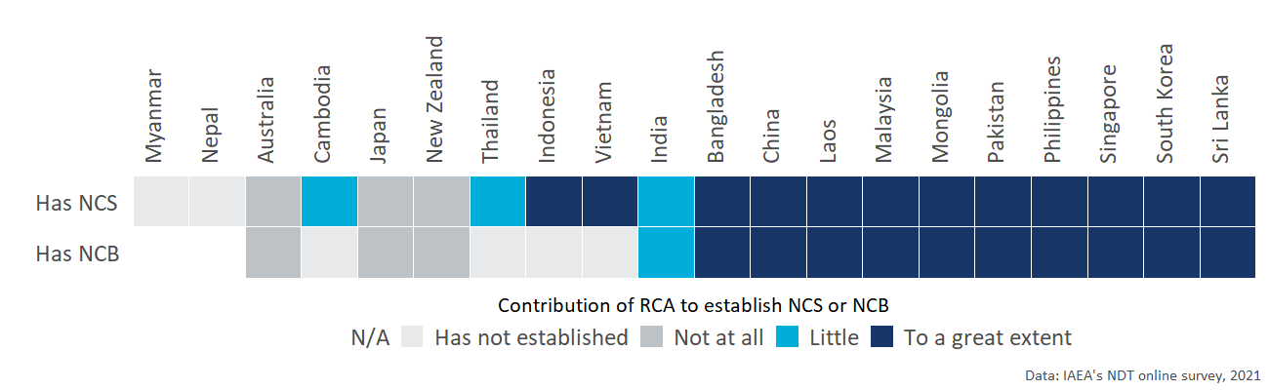

Figure 5: Contribution of RCA in GP’s infrastructure.

## Sub-criterion 1.2: NDT infrastructure to produce certified personnel

This section presents the findings on the extent to which the **NDT RCA has supported GPs in establishing NDT infrastructure through the RCA programme, and has enabled GPs to produce certified personnel in conventional methods (RT, UT, MT, PT, ET) and in advanced techniques** (RT-D, PAUT, TOFD, PEC, etc). The standards for this dimension are the following:

* **Adequate:** There are certified personnel produced by the national NDT certification scheme, however, for limited method(s) and not for all 5 main methods.
* **Good:** The support in establishing GPs’ NDT infrastructure through the RCA programme has enabled GPs to produce certified personnel in all levels of NDTs’ five main methods (RT, UT, MT, PT, ET) through the national NDT certification scheme.
* **Excellent:** The support in establishing GPs’ NDT infrastructure through the RCA programme has enabled GPs to produce certified personnel in all levels of NDTs’ five main methods (RT, UT, MT, PT, ET) through the national NDT certification scheme.

### Performance standards of “NDT infrastructure to produce certified personnel”

Figure 6 shows that based on the criterion developed with IAEA, **two countries have met an excellent standard (Singapore and South Korea) because RCA NDT has contributed or facilitated the introduction of all methods and techniques to their personnel**, and four GPs met a good standard (China, Mongolia, Pakistan, and Philippines) because the RCA NDT programme has facilitated the certification of their personnel in all the conventional techniques.

Laos, Myanmar, and Nepal are considered to have an inadequate performance because, according to responses provided by their experts, RCA NDT has not necessarily contributed to the certification of their personnel in any of these techniques.

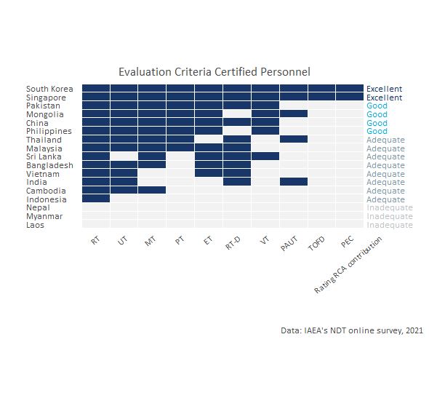

Figure 6: Personnel certified by methods: standards for self-reliance

### Contribution of the NDT RCA in the certification of personnel

As it can be seen in Table 1, **From 2000 to 2020, the NDT RCA programme has contributed, yearly, to the certification of roughly 12,657 personnel by local NDT Accredited Training Centres in 15 countries** (Bangladesh, Cambodia, China, India, Indonesia, Japan, Malaysia, Mongolia, Pakistan, Philippines, Singapore, South Korea, Sri Lanka, Thailand, and Vietnam). From the total certified personnel, **6.2% are female**.

The method for which RCA has contributed the most to the certification of personnel is Radiographic Testing (10,609 personnel trained), followed by Magnetic Testing and Penetrant Testing.

*As can be seen in the table below, it is possible that RCA NDT programme has indeed sensitised and provided awareness in GPs for the introduction of certification in the main and advanced NDT techniques. For some countries, “RCA had helped introduce and sensitise the NDT programme in the early years of cooperation. However, in the last 20 years, NDT centres in the country did conduct training and certification programmes under the national NDT Society and others but they have not been, necesarily, in association with RCA” (National expert, online survey 2021).* (National expert, online survey 2021).

Table 1: Number of certified personnel by country and technique

|  |  |  |  |  |  |  |
| --- | --- | --- | --- | --- | --- | --- |
| Method | Accronym | Type of technique | Average number of personnel certified per year under RCA | Approximate number of personnel certified from 2000 to 2020 under RCA | (%) of Certified female personnel | Countries supported by RCA NDT |
| Radiographic Testing | RT | Conventional | 10,609 | 212,180 | 5.15% | 15 |
| Ultrasonic Testing | UT | Conventional | 533 | 10,660 | 10.1% | 13 |
| Magnetic Testing | MT | Conventional | 594 | 11,880 | 13.18% | 12 |
| Penetrant Testing | PT | Conventional | 550 | 11,000 | 12.59% | 9 |
| Eddy Current Testing | ET | Conventional | 187 | 3,740 | 7.03% | 11 |
| Visual Testing | VT | Conventional | 119 | 2,380 | 7.16% | 7 |
| Radiographic Testing - Digital | RT-D | Advanced technique | 37 | 740 | 14.54% | 10 |
| Phased Array Ultrasonic Testing | PAUT | Advanced technique | 14 | 280 | 20% | 5 |
| Time of Flight Diffraction | TOFD | Advanced technique | 7 | 140 | 20% | 2 |
| Pulsed Eddy Current | PEC | Advanced technique | 7 | 140 | 20% | 2 |
| Total | - | - | 12,657 | 253,140 | 6.17% | 15 |

The total number of **certified personnel under the RCA programme** by country, technique, and sex is presented in Figure 7 below.

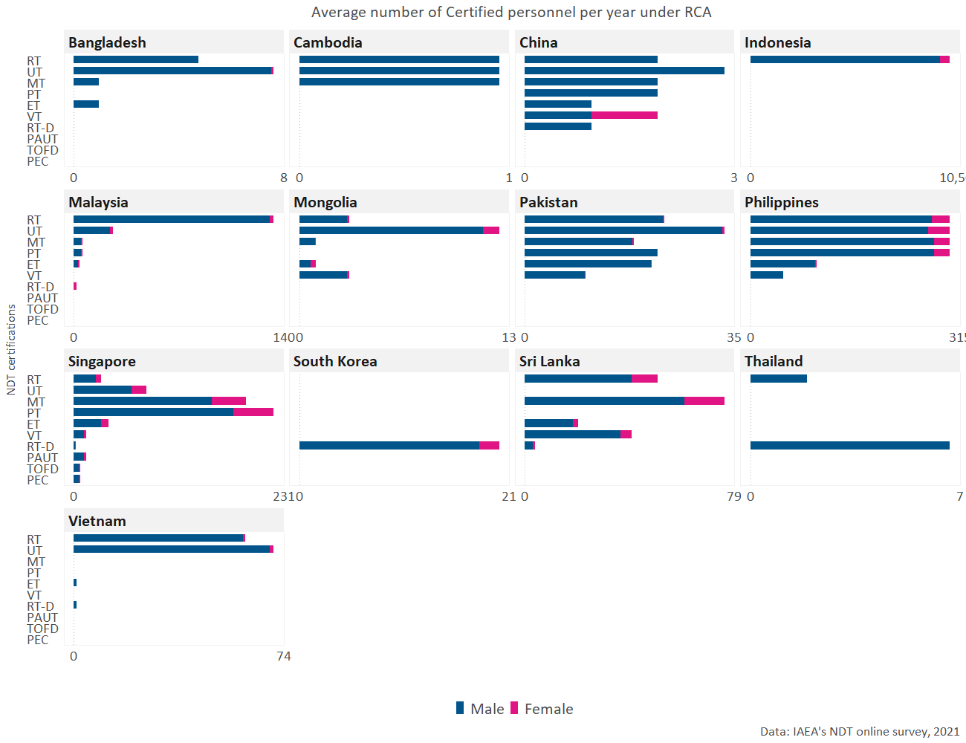

Figure 7: Number personnel certified by local NDT training centers as a result of participating in RCA NDT.

## Sub-criterion 1.3: Self reliance in NDT

Self reliance in NDT is a function of countries having the capacity to conduct inspection and train personnel without depending on external stakeholders. An assessment to map whether GPs have inspection and training centers owned locally or by foreigners was conducted to estimate the level of self-reliance that each GP has. According to the criterion developed, a GP is considered to have an excellent standard (or to have achieved increased self-reliance) if their local inspection and training centres offer their services abroad. On the other hand, the self-reliance of a GP is considered inadequate if it does not have both training and certification centres owned either by local or foreign firms.

The levels of performance for this criterion are the following:

* **Adequate:** GPs have training centres and inspection companies, owned by foreign entities.
* **Good:** GPs have local NDT training centres and inspection companies offering services to local industry.
* **Excellent:** GPs have achieved increased self-reliance in NDT, including offering training and inspection activities to local industries as well as abroad.

### Performance standards of “Self-reliance in NDT”

As it can be seen in Figure 8. Out of the 18 recipient countries, 5 (Malaysia, Pakistan, Singapore, South Korea, and Vietnam) offer both training and inspection abroad. Moreover, Myanmar and Nepal do have access to inspection centres (either owned locally or by foreigners) but they do not have training centres offering services in their countries.

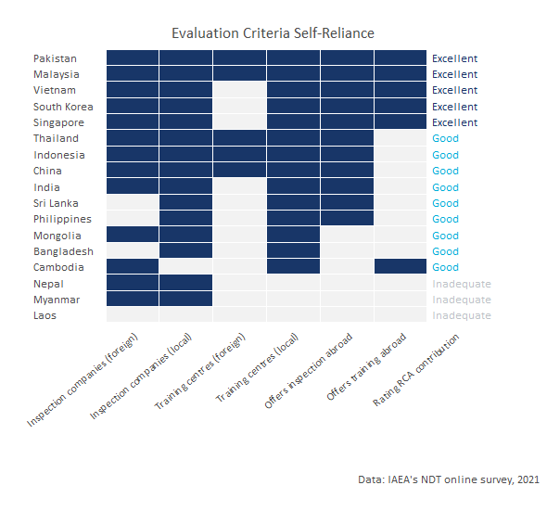

Figure 8: GP’s inspection and training centers: standards for self-reliance

### Contribution of RCA in the development of local inspection and training centers

According to the perception of respondents from the GPs, **the RCA NDT programme has contributed to a great extent in the establishment of inspection centres in nine of the twenty-two countries that are part of the programme** (Bangladesh, China, Indonesia, Malaysia, Pakistan, Philippines, Singapore, South Korea, and Vietnam); **in ten countries RCA has facilitated the investment in local inspection centres**; and, twelve countries perceived that RCA has contributed to a great extent in the establishment of local training centres (See Figure 9). An interesting finding is that although New Zealand has been an historical non-recipient country, their perception is that RCA has contributed to a great extent in the establishment of local training centres in their country.

The white asterisk in the figure below indicates that RCA has facilitated the investment in local inspection centres in those countries.

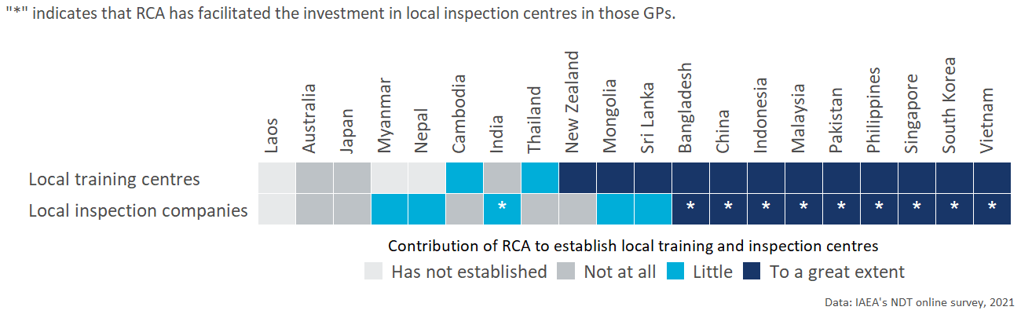

Figure 9: Contribution of the NDT RCA programme to the establishment of local inspection and training centres.

Figure 10 below shows the number of **inspection centres** owned by local and foreign firms in each RCA country. As it can be observed in the figure, **there are over 3,607 inspection centres owned by local firms across all the GPs that participate in the NDT RCA programme**.

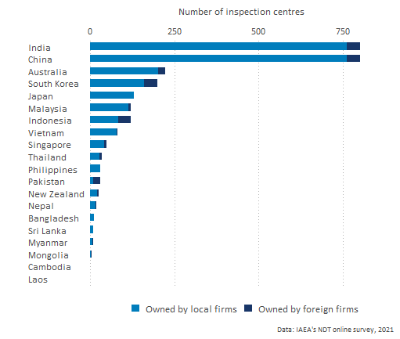

Figure 10: Number of inspection centres by type of ownership and country

Figure 11 below shows the number of **training centres** owned by local and foreign firms in each RCA country. Across all the GPs that are part of the NDT RCA programme, **There are a total of 191 training centres owned by local firms**.

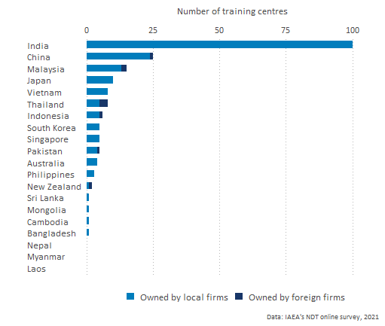

Figure 11: Number of training centres by type of ownership and country

# Criterion 2: Increased scope and scale of NDT demand and use

This section presents findings on the contribution of the NDT RCA programme to the increased scope and scale of NDT demand and use in the countries surveyed. Particularly, the analysis aims to understand the extent to which the support of the NDT programme has contributed to the enhancement of:

1. Awareness, interest, and application of NDT technology in the industrial sectors for the QA and QC of industrial components; and
2. Knowledge developed through R&D by publishing research articles, organising international and national seminars and conferences.

Key evidence for criterion 2: Increased scope and scale of NDT demand and use

|  |  |  |
| --- | --- | --- |
| Sub-criterion | Evidence | Finding |
| Awareness, interest, and application of NDT technology | % of recipient GPs that have taken actions to create awareness among industrial organisations about the benefits of NDT technology for Quality Assurance and Quality Control | 90% |
| Awareness, interest, and application of NDT technology | % of recipient GPs that have applied NDT technology for Quality Assurance and Quality Control in at least one industrial sector | 95% |
| Knowledge developed through R&D | % of GPS that have established any R&D activities related to NDT | 75% |
| Knowledge developed through R&D | Number of publications related to NDT that have been published since 2000 in as a result of being part of the RCA NDT programme | 1,620 |

Moreover, Figure 12 below shows the performance standards of the impact of NDT RCA programme on the increased scope and scale of NDT demand and use of the recipient Government Parties.

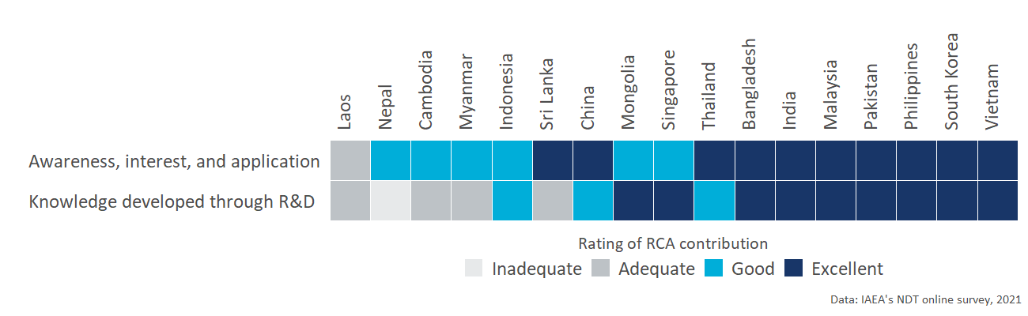

Figure 12: Increased scope and scale of NDT demand and use: Performance standard by criterion and country

The detailed analysis of each sub-criterion under improved NDT capacity and capability is presented in the sections below.

## Sub-criterion 2.1: Awareness, interest, and application

This sub-criterion explores **the extent into which participation in the RCA programme results in GPs applying NDT technology in the industrial sectors for the QA and QC** of industrial components, achieving better controlled manufacturing, lower production costs, ensuring material quality, and/or greater product integrity.

* **Adequate:** the NDT RCA programme has contributed to GPs initiating activities to create awareness among industrial organisations about the benefits of NDT technology for QA and QC.
* **Good:** as a result of being part of the NDT RCA programme, GPs become more concerned and interested in applying NDT technology in the industrial sectors; and an
* **Excellent:** Participating in the RCA programme results in GPs applying NDT technology in at least one industrial sector for the QA and QC of industrial components - achieving better controlled manufacturing, lower production costs, ensuring material quality, and/or greater product integrity.

### Performance standards of “Awareness, interest, and application of NDT technologies”

**Bangladesh, China, India, Malaysia, Pakistan, Philippines, South Korea, Sri Lanka, Thailand, and Vietnam are considered to have met an excellent performance standard** in this sub-criterion because, as a result of applying NDT technology, positive improvements have been achieved in terms of *controlled manufacturing, lower production costs, ensuring material quality or greater productivity for at least one industrial sector* (all the positive improvements by country and industrial sector is presented in the next section).

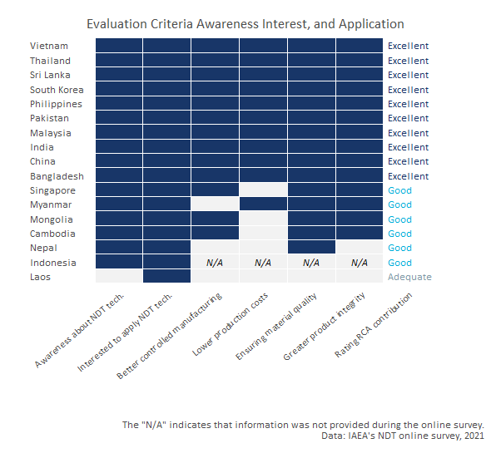

Figure 13: Performance standards: Awareness, interest, and application of NDT technology in the industrial sectors for the QA and QC of industrial components

Moreover, the **ten recipient GPs that met an excellent standard have taken actions to create awareness among industrial organisations about the benefits of NDT technology**. For all these GPs, being part of the RCA NDT programme has also contributed to increasing the level of concern and interest in applying NDT technologies for Quality Assurance and Quality Control in their industrial sectors.

Figure 13 shows the criterion and standards for this sub-dimension. **The N/A in the chart indicates that this information was not provided by those GPs during the online survey**. The detailed methodology and criteria is presented in Annex A.

### Contribution of the NDT RCA to awareness, interest, and application of NDT technologies

Table 2 shows that **ten of the GPs have taken actions to create awareness among industrial organisations about the benefits of NDT technology for Quality Assurance and Quality Control**. The table also shows the actions taken by these GPs.

Table 2: Actions taken by GPs to create awareness among industrial organisations about the benefits of NDT technology for Quality Assurance and Quality Control

|  |  |  |  |  |
| --- | --- | --- | --- | --- |
| Country | Has taken actions to create awarenes about benefits of NDT | Has conducted seminars, workshops and/or forums | Has engaged with policymakers and regulatory body(s) | Has conducted talks in universities or colleges |
| Australia | Yes | Yes | Yes | No |
| Bangladesh | Yes | Yes | Yes | Yes |
| Cambodia | Yes | Yes | Yes | Yes |
| China | Yes | Yes | Yes | Yes |
| India | Yes | Yes | Yes | Yes |
| Indonesia | Yes | Yes | Yes | Yes |
| Japan | No |  |  |  |
| Laos | No |  |  |  |
| Malaysia | Yes | Yes | Yes | Yes |
| Mongolia | Yes | No | Yes | No |
| Myanmar | Yes | Yes | Yes | Yes |
| Nepal | Yes |  |  |  |
| New Zealand | Yes | Yes | Yes | Yes |
| Pakistan | Yes | Yes | Yes | Yes |
| Philippines | Yes | Yes | Yes | Yes |
| Singapore | Yes | Yes | Yes | Yes |
| South Korea | Yes | Yes | Yes | Yes |
| Sri Lanka | Yes | Yes | No | Yes |
| Thailand | Yes | Yes | Yes | Yes |
| Vietnam | Yes | Yes | Yes | Yes |

The number of industrial sectors in which NDT technology has been applied for quality control and quality assurance in each GP is presented in Figure 12 below.

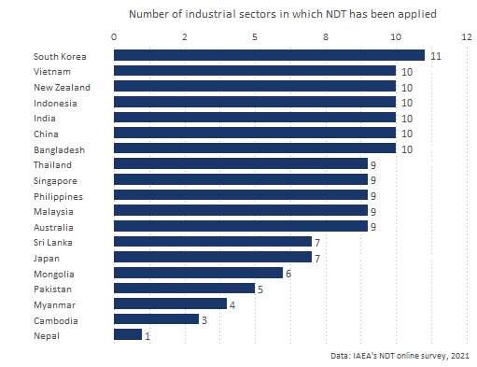

Figure 14: Number of industrial sectors in which NDT technology has been applied by GP

The extent to which the introduced NDT technology by the RCA programme led to improved manufacturing processes, lower production costs, enhanced material quality, and greater product integrity in each industrial sector is presented in Annex B. *For some countries, the information is missing because they did not provide this information in the online survey*.

## Sub-criterion 2.2: Research and Development

This section aims to understand the extent into which the NDT RCA programme has contributed to the dissemination of knowledge developed through R&D.

The standards for this criterion are the following:

* **Adequate:** GPs have successfully managed to train personnel in the introduced NDT technology.
* **Good** The NDT RCA programme has enable GPs to have successfully applied the NDT technology to local industry, and established R&D activities.
* **Excellent** As a result of participating in the NDT RCA programme, GPs have managed to support the utilisation of the technology by industry and disseminate the knowledge developed through R&D by publishing research articles, organising international and national seminars and conferences.

### Performance standards of “Research and Development”

**From the 18 recipient GPs that participated in the study, nine GPs (Bangladesh, India, Malaysia, Mongolia, Pakistan, Philippines, Singapore, South Korea, and Vietnam) met an excellent performance in R&D** because as a result of participating in the NDT RCA programme, they have published research articles, and have organized international and national seminars and conferences.

Because China, Indonesia, and Thailand **have established R&D activities but have not published or organized seminar under RCA**, their performance meets the defined standard for good performance in terms of R&D

Figure 15 shows the GPs’ performance in terms of R&D

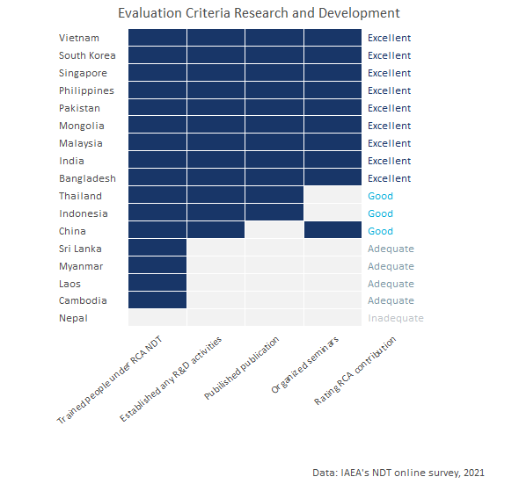

Figure 15: Performance standards: Research and Development

### Contribution of the NDT RCA in Research and Development

Figure 16 below shows the extent to which the RCA NDT programme enabled or promoted the initiation of R&D activities related to NDT. As can be seen in the chart, **RCA has contributed to a great extent to enable or promote the initiation of R&D in eight countries**. It is worth mentioning that although Japan has historically been a non-recipient country, they reported that RCA has contributed to a great extent in the promotion and initiation of R&D activities in their country.

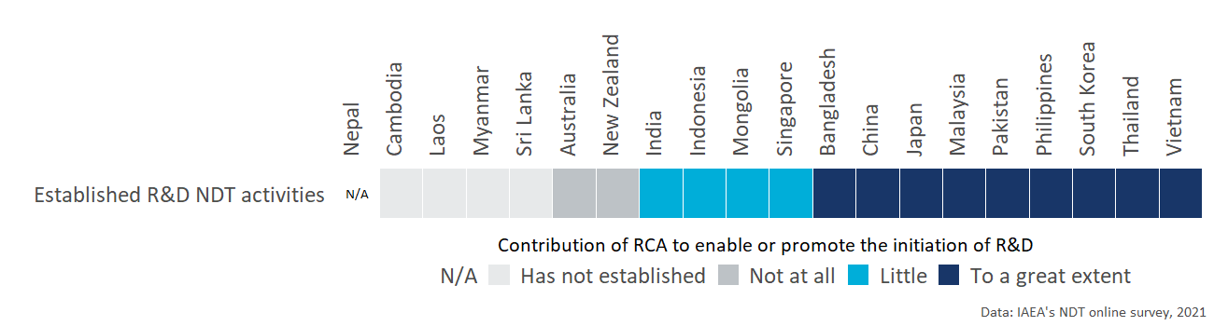

Figure 16: Extent to which the RCA NDT programme enabled or promoted the initiation of R&D activities related to NDT

**A total 2,674 personnel have been trained in NDT under the RCA NDT programme**. Figure 17 shows the number of personnel who have been trained in NDT under the RCA NDT programme by country

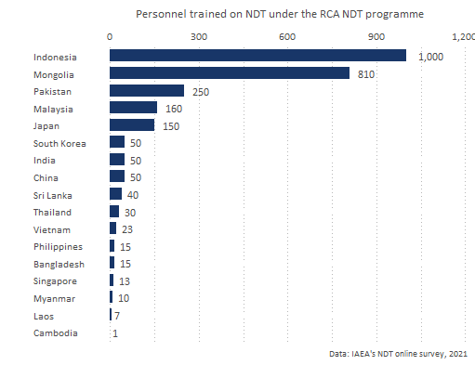

As can be seen in Figure 18, **since 2000 a total of 1,620 publications related to NDT have been published as a result of GPs being part of the RCA NDT programme**.

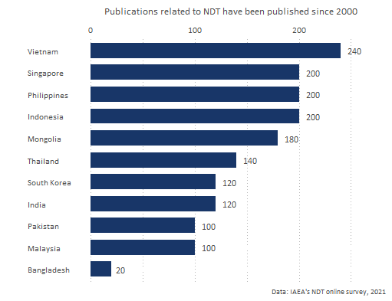

According to respondents **4,300 seminars/conferences related to NDT have been organised since 2000 as a result of GPs being part of the RCA NDT programme**. (See Figure 19).

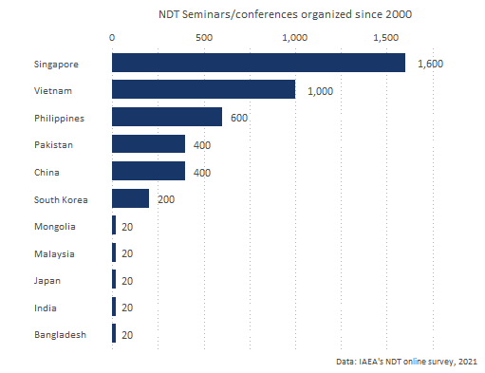

# Criterion 3: Improved health and safety

The aim of this section is to understand **the extent to which participating in the NDT RCA program** has enabled GPs to **apply NDT technology** in the industrial sectors as set by countries’ industrial laws for the QA and QC of industrial components and whether it has **resulted in improved health and safety outcomes** (i.e. fewer deaths and injuries) and/or reduced environmental pollution.

Key evidence is presented as follows. GPs were unable to provide estimates for some of the figures requested.

Key evidence for criterion 3: Improved health and safety

|  |  |  |
| --- | --- | --- |
| Criterion | Evidence | Finding |
| Improved health and safety | % of GPs reporting that the RCA NDT programme contributed to awareness of the benefits of using NDT technologies for safer operations of nuclear and other industrial installations | 85% |
| Improved health and safety | % of GPs reporting that the RCA NDT programme contributed to applying NDT technologies for safer operation of nuclear and other industrial installations | 85% |
| Improved health and safety | Approximate number of injuries prevented in the industrial sector since 2000 as a result of applying NDT technologies | *GPs do not have an approximation* |
| Improved health and safety | Approximate number of deaths prevented in the industrial sector since 2000 as a result of applying NDT technologies | *GPs do not have an approximation* |
| Improved health and safety | Approximate reduction of chemical waste (in tonnes) since 2000 as a result of applying NDT technologies | *GPs do not have an approximation* |

Moreover, figure 12 below shows the performance standards of the impact of NDT RCA programme on the Improved health and safety criteria.

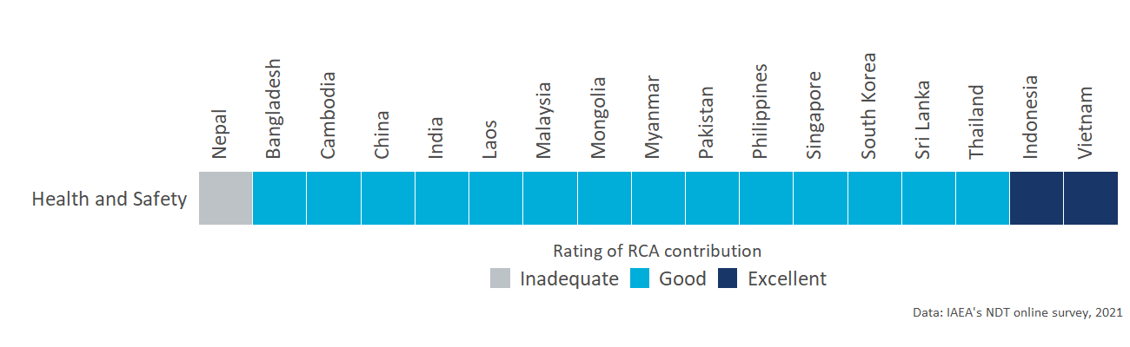

Figure 20: Improved health and safety: Performance standard by criterion and country

The detailed analysis of each sub-criterion under improved NDT capacity and capability is presented in the sections below.

### Performance standards of “Improved Health and Safety”

* **Adequate:** Participation in the RCA program results in GPs becoming more aware of the benefits of NDT technology for safer operation of nuclear and other industrial installations.
* **Good:** Participation in the RCA program results in GPs applying NDT technology for safer operation of nuclear and other industrial installations.
* **Excellent:** As a result of participation in the RCA program, GPs have been applying NDT technology in the industrial sectors as set by countries’ industrial laws for the QA and QC of industrial components, resulting in improved health and safety outcomes (i.e. fewer deaths and injuries) and/or reduced environmental pollution.

Figure 21 shows the standards met for this dimension. It is worth mentioning that all the countries except for Vietnam and Indonesia reported that their country does not have an approximation of the reduction of chemical waste, reduced injuries, or reduced deaths.

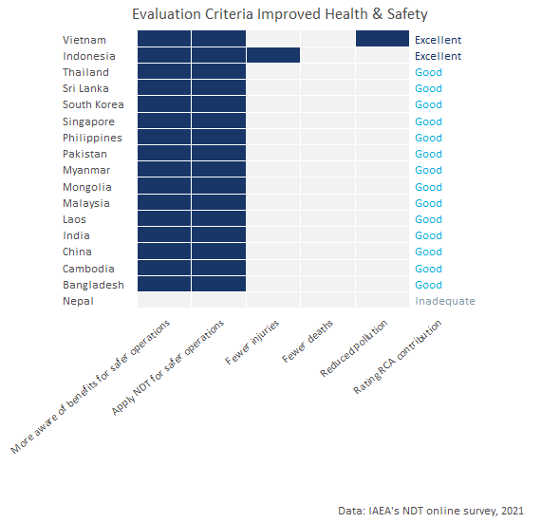

Figure 21: Performance standards: Improved Health and Safety

### Contribution of the NDT RCA in Improved Health and Safety

* **85% of all the GP’s reported that being part of the RCA NDT programme contributed to the aeareness of the benefits of using NDT technologies for safer operations** of nuclear and other industrial installations in their country.
* **85% of all the recipient GP’s reported that being part of the RCA NDT programme contributed to applying NDT technologies for safer operations** of nuclear and other industrial installations in their country.
* All GPs but two reported that their country does not have an approximation of the reduction of chemical waste, reduced injuries, or reduced deaths.

# Overall impact of the NDT RCA programme

This section aims to summarise the overall role of IAEA/RCA activities in achieving the general objectives and benefits of NDT on socio economic impact through industrial growth in each GP that is part of the programme.

Figure 22 shows the perception of the GP respondents on the role that RCA has had to:

* Help speed up the adoption of NDT technologies since 2000.
* Contribute to the adoption of NDT technologies by private businesses since 2000.
* The productivity of NDT inspections (reduction of the average time to complete an inspection).

According to experts who participated in the online survey, **for 83% of the recipient GPs, RCA NDT has helped to speed up the adoption of NDT technologies in their country since 2000**. For Bangladesh, India, Indonesia, Laos, Malaysia, and Myanmar the adoption occurred 1-3 years faster. Moreover, China, Mongolia, Pakistan, Philippines, Singapore, Thailand, and Vietnam reported that NDT RCA contributed for the adoption of NDT technologies to happen 4-5 years faster; and **South Korea and Sri Lanka considered that the adoption occurred 6-10 years faster than with out the support of IAEA.**

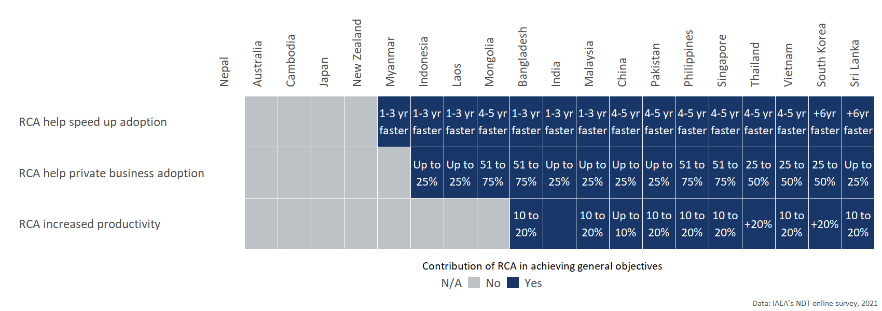

Figure 22: Contribution of IAEA/RCA activities in achieving general objectives and benefits by GP

Additionally, **78% of the GPs reported that NDT RCA contributed to the adoption of NDT technologies by private business in their countries since 2000**. From these countries, **50% estimated that the proportion of the total activity in their NDT sector can be attributed to RCA at least 25% or more.**

South Korea, Thailand, and Vietnam estimated that between 25% - 50% of total activity in the NDT sector in 2020 can be attributed to the RCA. And Bangladesh, Mongolia, Philippines, and Singapore estimated that between 51% - 75% can be attributed to the RCA.

Finally, Figure 23 shows how every GP evaluated the role of IAEA/RCA activities in achieving the general objectives and benefits of NDT on socio economic impact through industrial growth in their country. Their assessment is the following:

* **10 out of the 18 recipient GPs reported that the role of IAEA/RCA activities in achieving the general objectives and benefits of NDT on socio-economic impact through industrial growth in their countries is excellent.**
* 4 of the recipient GPS and 1 of the non-recipient (Japan) consider that RCA NDT role in achieving the general objectives of NDT in their country is good.
* From the GPs that consider the role of RCA has been poor, two are non-recipient countries (Australia, and New Zealand), and one (Cambodia) joint RCA NDT in 2018.

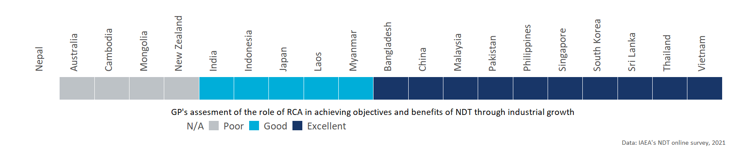

Figure 23: Contribution of IAEA/RCA activities in achieving general objectives and benefits by GP

# Annex A: Criteria and standards

|  |  |
| --- | --- |
| **Standard applied to each GP** | **Criterion 1: Improved NDT capacity and capability** |
| **Excellent** (exceeding expectations)    GPs with excellent status meet the standard for Good, plus: | **GPs have fulfilled the MRA requirements of ICNDT** as a result of the support under the RCA programme of IAEA.   * NDT Society is registered with APFNDT and ICNDT * The society is a signatory to ICNDT MRA * NCB for NDT accredited to ISO 17024 * NCB accepted for registration under the ICNDT MRA * Accredited training centres offering ISO 9712 training.   The support in establishing GPs’ NDT infrastructure through the RCA programme has enabled **GPs to produce *certified personnel in advanced techniques (RT-D, PAUT, TOFD, PEC, etc)*, in addition to the conventional methods (RT, UT, MT, PT, ET).**  GPs have achieved increased self-reliance in NDT, including offering training and inspection activities to local industries as well as abroad. |
| **Good** (meeting expectations)  GPs with good status meet the standard for Adequate, plus: | **GPs have established internationally-recognised NDT infrastructure at the national leve**l as a result of the support under the RCA programme of IAEA.   * NDT Society has been established * National certification body on NDT has been established. * Local NDT training centres are offering ISO 9712 training   The support in establishing GPs’ NDT infrastructure through the RCA programme has enabled **GPs to produce certified personnel in all levels of NDTs’ *five main methods* (RT, UT, MT, PT, ET)** through the national NDT certification scheme.[^Since most national certification schemes started late compared to other certification, acceptance is the main challenge.]  GPs have local NDT training centres and inspection companies offering services to local industry. |
| **Adequate** (meeting bottom-line expectations) | GPs have established **basic NDT infrastructure at the national level** as a result of the support under the RCA programme of IAEA.  National certification scheme has been established and there are **certified personnel produced by the national NDT certification scheme, however, for limited method(s) and not for all 5 main methods.**  There are trained personnel at the GP organisation level.  GPs have training centres and inspection companies, owned by foreign entities. |
| **Inadequate** | The level of NDT infrastructure is below the standard for Adequate |

|  |  |
| --- | --- |
| **Standard applied to each GP** | **Criterion 2: Increased scope and scale of NDT demand and use** |
| **Excellent** (exceeding expectations)  GPs with excellent status meet the standard for Good, plus: | From the involvement in the RCA programme, **GPs have managed to support the utilisation of the technology by industry and disseminate the knowledge developed through R&D** by publishing research articles, organising international and national seminars and conferences.  **Participation in the RCA programme results in GPs applying NDT technology in the industrial sectors for the QA and QC of industrial components** - achieving better controlled manufacturing, lower production costs, ensuring material quality, and/or greater product integrity. |
| **Good** (meeting expectations)  GPs with good status meet the standard for Adequate, plus: | From the involvement in the RCA programme, **GPs have successfully applied the NDT technology to local industry, and established R&D activities**.  **Participation in the RCA programme results in GPs becoming more concerned and interested, and starting to apply NDT technology** in the industrial sectors for the QA and QC of industrial components. |
| **Adequate** (meeting bottom-line expectations) | From the involvement in the RCA programme, **GPs have successfully managed to train personnel in the introduced technology**.  **Participation in the RCA programme of IAEA results in GPs initiating activities to create awareness** among industrial organisations about the benefits of NDT technology for QA and QC. |
| **Inadequate** | Any of the standards for Adequate are not met. |

|  |  |
| --- | --- |
| **Standard applied to each GP** | **Criterion 3: Improved health and safety** |
| **Excellent** (exceeding expectations)  GPs with excellent status meet the standard for Good, plus: | As a result of participation in the RCA program of IAEA, **GPs have been applying NDT technology** in the industrial sectors as set by countries’ industrial laws for the QA and QC of industrial components - **resulting in  improved health and safety outcomes** (i.e. fewer deaths and injuries) and/or reduced environmental pollution. |
| **Good** (meeting expectations)  GPs with good status meet the standard for Adequate, plus: | Participation in the RCA program of IAEA results in **GPs applying NDT technology for safer operation** of nuclear and other industrial installations. |
| **Adequate** (meeting bottom-line expectations) | Participation in the RCA program of IAEA results in **GPs becoming more aware of the benefits of NDT technology for safer operation** of nuclear and other industrial installations. |
| **Inadequate** | Any of the standards for Adequate are not met. |

# Annex B: Implementation of NDT technology by industrial sector

Table 3: Extent to which the introduced NDT technology by the RCA programme led to improved manufacturing processes

|  |  |  |  |  |  |  |
| --- | --- | --- | --- | --- | --- | --- |
| Country | Industrial Sector | NDT has caused positive improvements in Controlled manufacturing | NDT has caused positive improvements in Ensuring material quality | NDT has caused positive improvements in Greater product integrity | NDT has caused positive improvements in Lower production costs | (%) by which production costs are lower between 2000 and 2020 |
| Australia | Aerospace |  |  |  |  |  |
| Australia | Chemical |  |  |  |  |  |
| Australia | Construction |  |  |  |  |  |
| Australia | Manufacturing |  |  |  |  |  |
| Australia | Oil and gas |  |  |  |  |  |
| Australia | Petrochemical |  |  |  |  |  |
| Australia | Power generation (excluding nuclear) |  |  |  |  |  |
| Australia | Railway |  |  |  |  |  |
| Australia | Shipping |  |  |  |  |  |
| Bangladesh | Aerospace | No | Yes | Yes | No |  |
| Bangladesh | Chemical | Yes | Yes | Yes | Yes | Moderate decrease (5% decrease) |
| Bangladesh | Construction | No | Yes | Yes | No |  |
| Bangladesh | Manufacturing | Yes | Yes | Yes | Yes | Moderate decrease (5% decrease) |
| Bangladesh | Nuclear | No | Yes | Yes | No |  |
| Bangladesh | Oil and gas | Yes | Yes | Yes | Yes | Moderate decrease (5% decrease) |
| Bangladesh | Petrochemical | Yes | Yes | Yes | Yes | Moderate decrease (5% decrease) |
| Bangladesh | Power generation (excluding nuclear) | Yes | Yes | Yes | Yes | Moderate decrease (5% decrease) |
| Bangladesh | Railway | No | Yes | Yes | No |  |
| Bangladesh | Shipping | Yes | Yes | Yes | Yes | Moderate decrease (5% decrease) |
| Cambodia | Construction | Yes | Yes | Yes | No |  |
| Cambodia | Manufacturing | Yes | Yes | Yes | No |  |
| Cambodia | Oil and gas | Yes | Yes | Yes | No |  |
| China | Aerospace | Yes | Yes | Yes | Yes | Significant decrease (10% decrease or more) |
| China | Chemical | Yes | Yes | Yes | Yes | Significant decrease (10% decrease or more) |
| China | Construction | Yes | Yes | Yes | Yes | Significant decrease (10% decrease or more) |
| China | Manufacturing | Yes | Yes | Yes | Yes | Significant decrease (10% decrease or more) |
| China | Nuclear | Yes | Yes | Yes | Yes | Significant decrease (10% decrease or more) |
| China | Oil and gas | Yes | Yes | Yes | Yes | Significant decrease (10% decrease or more) |
| China | Petrochemical | Yes | Yes | Yes | Yes | Significant decrease (10% decrease or more) |
| China | Power generation (excluding nuclear) | Yes | Yes | Yes | Yes | Significant decrease (10% decrease or more) |
| China | Railway | Yes | Yes | Yes | Yes | Significant decrease (10% decrease or more) |
| China | Shipping | Yes | Yes | Yes | Yes | Significant decrease (10% decrease or more) |
| India | Aerospace | Yes | Yes | Yes | Yes |  |
| India | Chemical | Yes | Yes | Yes | Yes |  |
| India | Construction |  |  |  |  |  |
| India | Manufacturing | Yes | Yes | Yes | Yes |  |
| India | Nuclear | Yes | Yes | Yes | Yes |  |
| India | Oil and gas | Yes | Yes | Yes | Yes | Small decrease (1% decrease) |
| India | Petrochemical | Yes | Yes | Yes | No |  |
| India | Power generation (excluding nuclear) | Yes | Yes | Yes | Yes |  |
| India | Railway | Yes | Yes | Yes | Yes |  |
| India | Shipping | Yes | Yes | Yes | Yes |  |
| Indonesia | Aerospace |  |  |  |  |  |
| Indonesia | Chemical |  |  |  |  |  |
| Indonesia | Construction |  |  |  |  |  |
| Indonesia | Manufacturing |  |  |  |  |  |
| Indonesia | Nuclear |  |  |  |  |  |
| Indonesia | Oil and gas |  |  |  |  |  |
| Indonesia | Petrochemical |  |  |  |  |  |
| Indonesia | Power generation (excluding nuclear) |  |  |  |  |  |
| Indonesia | Railway |  |  |  |  |  |
| Indonesia | Shipping |  |  |  |  |  |
| Japan | Chemical | Yes | Yes | Yes | No |  |
| Japan | Construction | Yes | Yes | Yes | No |  |
| Japan | Manufacturing | Yes | Yes | Yes | No |  |
| Japan | Nuclear | Yes | Yes | Yes | No |  |
| Japan | Oil and gas | Yes | Yes | Yes | No |  |
| Japan | Petrochemical | Yes | Yes | Yes | No |  |
| Japan | Shipping | Yes | Yes | Yes | No |  |
| Malaysia | Aerospace | No | Yes | Yes | No |  |
| Malaysia | Chemical | No | Yes | Yes | No |  |
| Malaysia | Construction | Yes | Yes | Yes | Yes | Significant decrease (10% decrease or more) |
| Malaysia | Manufacturing | Yes | Yes | Yes | Yes | Significant decrease (10% decrease or more) |
| Malaysia | Oil and gas | No | Yes | Yes | No |  |
| Malaysia | Petrochemical | No | Yes | Yes | No |  |
| Malaysia | Power generation (excluding nuclear) | No | Yes | Yes | No |  |
| Malaysia | Railway | No | Yes | Yes | No |  |
| Malaysia | Shipping | No | Yes | Yes | No |  |
| Mongolia | Aerospace | No | Yes | Yes | No |  |
| Mongolia | Construction | No | Yes | No | No |  |
| Mongolia | Oil and gas |  |  |  |  |  |
| Mongolia | Petrochemical | No | Yes | No | No |  |
| Mongolia | Power generation (excluding nuclear) | Yes | Yes | No | No |  |
| Mongolia | Railway | Yes | Yes | No | No |  |
| Myanmar | Construction | No | Yes | Yes | No |  |
| Myanmar | Oil and gas | No | Yes | No | No |  |
| Myanmar | Petrochemical | No | No | Yes | Yes | Small decrease (1% decrease) |
| Myanmar | Shipping | No | Yes | Yes | No |  |
| Nepal | Construction | No | Yes | No | No |  |
| New Zealand | Aerospace | Yes | Yes | Yes | No |  |
| New Zealand | Chemical | Yes | Yes | Yes | No |  |
| New Zealand | Construction | Yes | Yes | Yes | No |  |
| New Zealand | Manufacturing | Yes | Yes | Yes | No |  |
| New Zealand | Oil and gas | Yes | Yes | Yes | No |  |
| New Zealand | Other | Yes | Yes | Yes | No |  |
| New Zealand | Petrochemical | Yes | Yes | Yes | No |  |
| New Zealand | Power generation (excluding nuclear) | Yes | Yes | Yes | No |  |
| New Zealand | Railway | No | Yes | Yes | No |  |
| New Zealand | Shipping | Yes | Yes | Yes | No |  |
| Pakistan | Manufacturing | Yes | Yes | Yes | Yes | Moderate decrease (5% decrease) |
| Pakistan | Nuclear | Yes | Yes | Yes | Yes | Moderate decrease (5% decrease) |
| Pakistan | Oil and gas | Yes | Yes | Yes | Yes | Moderate decrease (5% decrease) |
| Pakistan | Petrochemical | Yes | Yes | Yes | Yes | Moderate decrease (5% decrease) |
| Pakistan | Power generation (excluding nuclear) | Yes | Yes | Yes | Yes | Significant decrease (10% decrease or more) |
| Philippines | Aerospace | Yes | Yes | Yes | Yes | Significant decrease (10% decrease or more) |
| Philippines | Chemical | Yes | Yes | Yes | Yes | Moderate decrease (5% decrease) |
| Philippines | Construction | Yes | Yes | Yes | Yes | Significant decrease (10% decrease or more) |
| Philippines | Manufacturing | Yes | Yes | Yes | Yes | Moderate decrease (5% decrease) |
| Philippines | Oil and gas | Yes | Yes | Yes | Yes | Significant decrease (10% decrease or more) |
| Philippines | Petrochemical | Yes | Yes | Yes | Yes | Moderate decrease (5% decrease) |
| Philippines | Power generation (excluding nuclear) | Yes | Yes | Yes | Yes | Significant decrease (10% decrease or more) |
| Philippines | Railway | Yes | Yes | Yes | Yes | Moderate decrease (5% decrease) |
| Philippines | Shipping | Yes | Yes | Yes | Yes | Significant decrease (10% decrease or more) |
| Singapore | Aerospace | Yes | Yes | Yes | No |  |
| Singapore | Chemical | Yes | Yes | Yes | No |  |
| Singapore | Construction | Yes | Yes | Yes | No |  |
| Singapore | Manufacturing | Yes | Yes | Yes | No |  |
| Singapore | Oil and gas | Yes | Yes | Yes | No |  |
| Singapore | Petrochemical | Yes | Yes | Yes | No |  |
| Singapore | Power generation (excluding nuclear) | Yes | Yes | Yes | No |  |
| Singapore | Railway | Yes | Yes | Yes | No |  |
| Singapore | Shipping | Yes | Yes | Yes | No |  |
| South Korea | Aerospace | Yes | Yes | Yes | No |  |
| South Korea | Chemical | Yes | Yes | Yes | Yes | Significant decrease (10% decrease or more) |
| South Korea | Construction | Yes | Yes | Yes | No |  |
| South Korea | Manufacturing | Yes | Yes | No | No |  |
| South Korea | Nuclear | Yes | Yes | Yes | Yes | Significant decrease (10% decrease or more) |
| South Korea | Oil and gas | Yes | Yes | Yes | Yes | Significant decrease (10% decrease or more) |
| South Korea | Other | Yes | Yes | Yes | Yes | Moderate decrease (5% decrease) |
| South Korea | Petrochemical | Yes | Yes | Yes | Yes | Significant decrease (10% decrease or more) |
| South Korea | Power generation (excluding nuclear) | Yes | Yes | Yes | Yes | Significant decrease (10% decrease or more) |
| South Korea | Railway | Yes | Yes | Yes | No |  |
| South Korea | Shipping | Yes | Yes | Yes | Yes | Significant decrease (10% decrease or more) |
| Sri Lanka | Aerospace | No | Yes | No | No |  |
| Sri Lanka | Construction | No | Yes | Yes | No |  |
| Sri Lanka | Manufacturing | Yes | Yes | Yes | Yes | Moderate decrease (5% decrease) |
| Sri Lanka | Oil and gas | Yes | Yes | Yes | Yes | Moderate decrease (5% decrease) |
| Sri Lanka | Petrochemical | Yes | Yes | Yes | Yes | Small decrease (1% decrease) |
| Sri Lanka | Power generation (excluding nuclear) | Yes | Yes | Yes | Yes | Moderate decrease (5% decrease) |
| Sri Lanka | Shipping | Yes | Yes | Yes | Yes | Moderate decrease (5% decrease) |
| Thailand | Aerospace | Yes | Yes | Yes | No |  |
| Thailand | Chemical | Yes | Yes | Yes | Yes | Moderate decrease (5% decrease) |
| Thailand | Construction | Yes | Yes | Yes | No |  |
| Thailand | Manufacturing | Yes | Yes | Yes | Yes | Significant decrease (10% decrease or more) |
| Thailand | Oil and gas | Yes | Yes | Yes | Yes | Moderate decrease (5% decrease) |
| Thailand | Petrochemical | Yes | Yes | Yes | Yes | Moderate decrease (5% decrease) |
| Thailand | Power generation (excluding nuclear) | Yes | Yes | Yes | No |  |
| Thailand | Railway | Yes | Yes | Yes | No |  |
| Thailand | Shipping | Yes | Yes | Yes | No |  |
| Vietnam | Aerospace | No | Yes | No | No |  |
| Vietnam | Chemical | Yes | Yes | Yes | Yes | Moderate decrease (5% decrease) |
| Vietnam | Construction | Yes | Yes | Yes | Yes | Moderate decrease (5% decrease) |
| Vietnam | Manufacturing | Yes | Yes | Yes | Yes | Moderate decrease (5% decrease) |
| Vietnam | Oil and gas | Yes | Yes | Yes | Yes | Moderate decrease (5% decrease) |
| Vietnam | Other | Yes | Yes | Yes | No |  |
| Vietnam | Petrochemical | Yes | Yes | Yes | Yes | Moderate decrease (5% decrease) |
| Vietnam | Power generation (excluding nuclear) | Yes | Yes | Yes | Yes | Moderate decrease (5% decrease) |
| Vietnam | Railway | Yes | Yes | Yes | Yes | Moderate decrease (5% decrease) |
| Vietnam | Shipping | Yes | Yes | Yes | Yes | Moderate decrease (5% decrease) |